## PROGRAM DEFINITION

|  |
| --- |
|  |
| * Program untuk menentukan system parameter yang digunakan untuk module Help Desk (HD) |

## RELATED TABLES

|  |  |
| --- | --- |
|  | **Access** |
| * HDM_SYSTEM_PARAM * HDM_SYSTEM_PARAM_NUMBERING * GSB_CODE_DT * GSM_PROPERTY | * RW * RW * R * R |

## ROLES

|  |  |
| --- | --- |
|  | **Test** |
| * User yg mempunyai akses ke program |  |

## INITIAL PROCESS

|  |  |
| --- | --- |
|  | **Test** |
| * Set VAR_COMPANY_ID = Login User’s Company ID * Set VAR_USER_ID = Login User ID * Set VAR_LANGUAGE_ID = Login User’s Language ID * Set VAR_SEQUENCE_00 = “” * Set VAR_SEQUENCE_01 = “” * Set VAR_SEQUENCE_02 = “” * Jalankan RSP_GS_GET_PROPERTY_LIST dengan parameter, simpan hasil ke VAR_SELECTED_PROPERTY   + VAR_COMPANY_ID   + VAR_LANGUAGE_ID * Jalankan RSP_HD_GET_SYSTEM_PARAM dengan parameter, simpan hasil ke VAR_SYSTEM_PARAM   + VAR_COMPANY_ID   + VAR_SELECTED_PROPERTY.CPROPERTY_ID * ~~Set VAR_PERIOD_MODE (as array of object) with VAR_CODE and VAR_NAME [CR02]~~ **[CR03]**   + ~~Set VAR_CODE = ‘N’, ‘P’, ‘Y’~~   + ~~Set VAR_NAME = None, Periodically, Yearly~~ * Jalankan RSP_GS_GET_GSB_CODE_LIST dengan parameter, simpan hasil ke VAR_PERIOD_MODE **[CR03]**   + ‘BIMASAKTI’   + VAR_COMPANY_ID   + ‘_NUMBERING_PERIOD_MODE’   + VAR_LANG_ID * Set VAR_YEAR_FORMAT (as array of object) with VAR_CODE and VAR_NAME [CR02]   + Set VAR_CODE = ‘01’, ‘02’   + Set VAR_NAME = ‘YY’, ‘YYYY’ * Jalankan RSP_GS_GET_GSB_CODE_LIST dengan parameter, simpan hasil ke VAR_DELIMITER [CR02]   + ‘BIMASAKTI’   + VAR_COMPANY_ID   + ‘_BS_REFNO_DELIMITER’   + VAR_LANG_ID |  |

## TAB SYSTEM PARAMETER

### USER INTERFACE

#### [CR03]

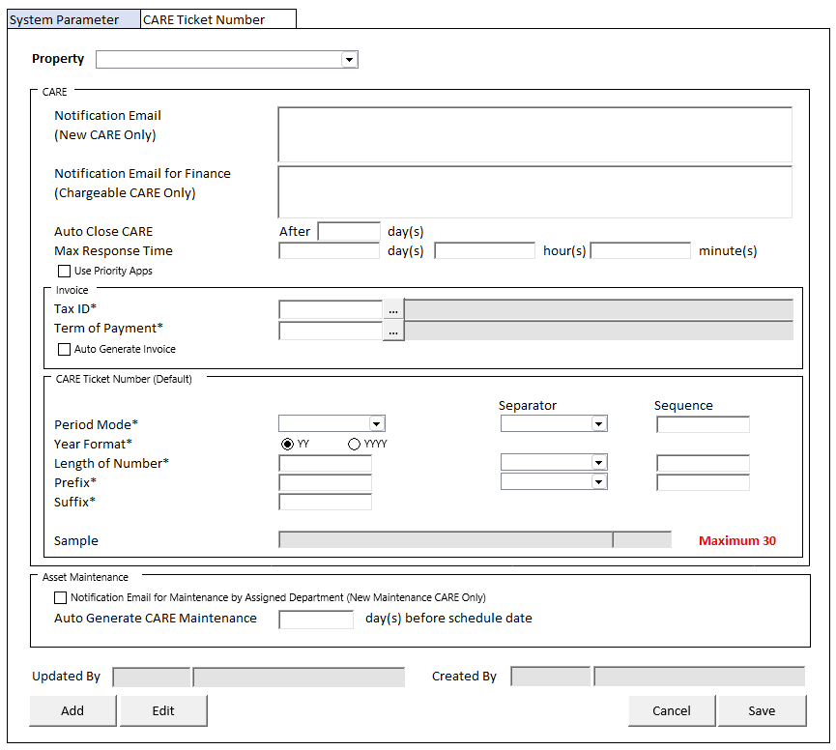

#### [CR02]

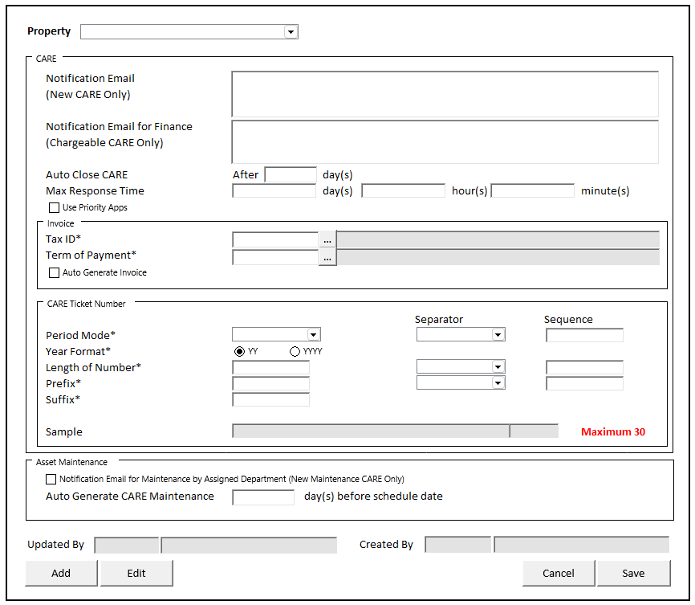

#### [CR01]

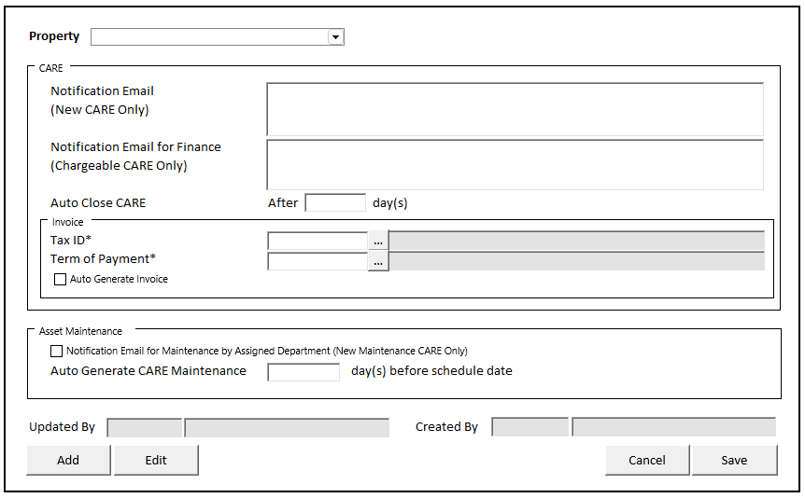

#### INITIAL VERSION

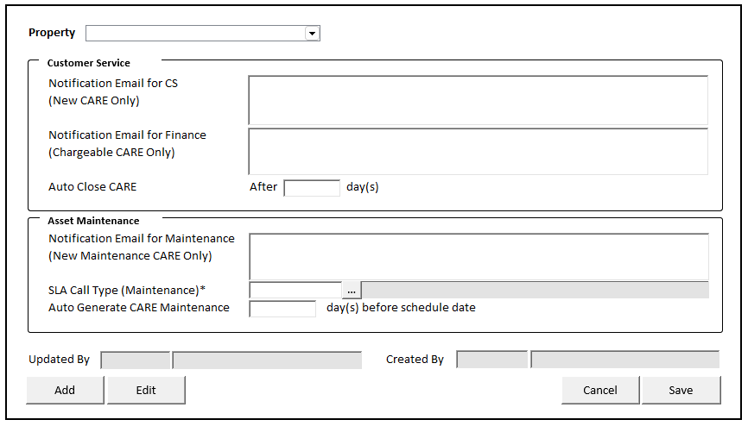

### TAB DEFINITION [CR03]

|  |  |  |
| --- | --- | --- |
| **Tab Name** | **Action** | **Enabled** |
| System Parameter | Go to Tab System Parameter | * + Always Enabled |
| CARE Ticket Number | Go to Tab CARE Ticket Number  With Parameter:   * PARAM_PROPERTY_ID = CPROPERTY_ID * PARAM_PROPERTY_NAME = CPROPERTY_NAME | * + VAR_SYSTEM_PARAM is not NULL |

### BUTTON DEFINITION

|  |  |  |
| --- | --- | --- |
| **Button Name** | **Action** | **Enabled** |
| Add | Jalankan ADD NEW PROCESS | * + NOT on CRUD Mode   Hidden IF:   * + VAR_SYSTEM_PARAM is not EMPTY |
| Edit | Jalankan EDIT PROCESS | * + NOT on CRUD Mode   Hidden IF:   * + VAR_SYSTEM_PARAM is EMPTY |
| Cancel | Go to DISPLAY PROCESS | * + On CRUD Mode |
| Save | Jalankan SAVE & VALIDATION PROCESS | * + On CRUD Mode |

### ROLES

|  |  |
| --- | --- |
|  | **Test** |
| * User yg punya akses ke program |  |

### INITIAL PROCESS

|  |  |
| --- | --- |
|  | **Test** |
|  |  |

### DISPLAY PROCESS

#### FIELD DEFINITION

|  |  |  |  |
| --- | --- | --- | --- |
| **Name** | **Field** | **Type** | **Validation** |
| Property | CPROPERTY_ID | Combobox  Isi combobox dengan RSP_GS_GET_PROPERTY_LIST dengan parameter   * VAR_COMPANY_ID * VAR_USER_ID   Set ValueField = CPROPERTY_ID  Set TextField = CPROPERTY_NAME  Simpan hasil ke VAR_SELECTED_PROPERTY | On Value Changed,  IF Active Tab = ‘System Parameter’  **Load System Parameter**  Jalankan RSP_HD_GET_SYSTEM_PARAM dengan parameter:   * + VAR_COMPANY_ID   + VAR_SELECTED_PROPERTY.CPROPERTY_ID |
| **Display Form** |  | **Data:** VAR_SYSTEM_PARAM |  |
| **CARE** |  |  |  |
| Notification Email ~~for CS~~  [CR01] | CEMAIL_CS  Subtitle:  (New CARE Only) | TextArea, Disabled | Max Length = 500  Enabled: on ADD & EDIT |
| Notification Email for Finance | CEMAIL_FINANCE | TextArea, Disabled | Max Length = 500  Enabled: on ADD & EDIT |
| Auto Close CARE | IAUTO_CLOSE_DAYS  Subtitle:  After … day(s) | NumericTextbox, Disabled, Required | No Arrows  Decimal Places = 0  Enabled: on ADD & EDIT |
| Max Response Time [CR02] | IRESPONSE_DAYS | NumericTextbox, Disabled | No Arrows  Decimal Places = 0  Enabled: on ADD & EDIT  Set Default = 0 |
| IRESPONSE_HOURS | NumericTextbox, Disabled | No Arrows  Decimal Places = 0  Enabled: on ADD & EDIT  Set Default = 0  Min Value = 0  Max Value = 24 |
| IRESPONSE_MINUTES | NumericTextbox, Disabled | No Arrows  Decimal Places = 0  Enabled: on ADD & EDIT  Set Default = 0  Min Value = 0  Max Value = 60 |
| Use Priority Apps | LCARE_PRIORITY | Checkbox, Disabled | Enabled: on ADD & EDIT |
| **INVOICE** |  |  |  |
| Tax ID  [CR01] | CTAX_ID | Textbox, Disabled, Required | Enabled: on ADD & EDIT  On Lost Focus  Go to 🡪 TAX ID LOOKUP PROCESS  On value change, update:  CTAX_ID, CTAX_NAME |
| Lookup, Disabled | Enabled: on ADD & EDIT  On Lookup Button clicked:  Go to 🡪 TAX ID LOOKUP PROCESS  On value change, update:  CTAX_ID, CTAX_NAME |
| CTAX_NAME | Textbox, Disabled |  |
| Term of Payment  [CR01] | CPAY_TERM_CODE | Textbox, Disabled, Required | Enabled: on ADD & EDIT  On Lost Focus  Go to 🡪 PAYMENT TERM LOOKUP PROCESS  On value change, update:  CPAY_TERM_CODE, CPAY_TERM_NAME |
|  |  | Lookup, Disabled | Enabled: on ADD & EDIT  On Lookup Button clicked:  Go to 🡪 PAYMENT TERM LOOKUP PROCESS  On value change, update:  CPAY_TERM_CODE, CPAY_TERM_NAME |
|  | CPAY_TERM_NAME | Textbox, Disabled |  |
| Auto Generate Invoice  [CR01] | LAUTO_GENERATE_INVOICE | Checkbox, Disabled | Enabled: on ADD & EDIT  Default Value: FALSE |
| **~~CARE Ticket Number~~**  **[CR03]**  **CARE Ticket Number (Default) [CR03]** |  |  |  |
| Period Mode  [CR02] | CPERIOD_MODE | Combobox, Disabled, Required  Isi combobox dengan VAR_PERIOD_MODE  Set ValueField = VAR_CODE  Set TextField = VAR_NAME  Simpan hasil ke CPERIOD_MODE | Enabled: on ADD & EDIT  Set Default = “Y”  On Value Changed,  Set CPERIOD_MODE_DISPLAY =  IF CPERIOD_MODE = N, then “”  IF CPERIOD_MODE = P, then CYEAR_FORMAT + “MM” + CPERIOD_MODE_SEPARATOR  IF CPERIOD_MODE = Y, then CYEAR_FORMAT + CPERIOD_MODE_SEPARATOR |
| CPERIOD_MODE_SEPARATOR | Combobox, Disabled, Required  Isi combobox dengan VAR_DELIMITER  Set ValueField = CCODE  Set TextField = CNAME  Simpan hasil ke CPERIOD_MODE_SEPARATOR | Enabled: on ADD & EDIT  Set Default = “/”  On Value Changed,  Set CPERIOD_MODE_DISPLAY =  IF CPERIOD_MODE = N, then “”  IF CPERIOD_MODE = P, then CYEAR_FORMAT + “MM” + CPERIOD_MODE_SEPARATOR  IF CPERIOD_MODE = Y, then CYEAR_FORMAT + CPERIOD_MODE_SEPARATOR |
| IPERIOD_MODE_SEQUENCE | NumericTextbox, Disabled, Required | Enabled: on ADD & EDIT  Decimal Places = 0  MinValue = 1  MaxValue = 2  Set Default = 1  On Value Changed,  Set CPERIOD_MODE_DISPLAY =  IF CPERIOD_MODE = N, then “”  IF CPERIOD_MODE = P, then CYEAR_FORMAT + “MM” + CPERIOD_MODE_SEPARATOR  IF CPERIOD_MODE = Y, then CYEAR_FORMAT + CPERIOD_MODE_SEPARATOR  IF IPERIOD_MODE_SEQUENCE = 1, then  Set INUMBER_LENGTH_SEQUENCE = 2  Set VAR_SEQUENCE_01 = CPERIOD_MODE_DISPLAY  ELSE IF IPERIOD_MODE_SEQUENCE = 2, then  Set INUMBER_LENGTH_SEQUENCE = 1  Set VAR_SEQUENCE_02 = CPERIOD_MODE_DISPLAY |
| Year Format [CR02] | CYEAR_FORMAT | Combobox, Disabled, Required  Isi combobox dengan VAR_YEAR_FORMAT  Set ValueField = VAR_CODE  Set TextField = VAR_NAME  Simpan hasil ke CYEAR_FORMAT | Enabled: on ADD & EDIT  Set Default = ‘02’  Set CPERIOD_MODE_DISPLAY =  IF CPERIOD_MODE = N, then “”  IF CPERIOD_MODE = P, then CYEAR_FORMAT + “MM” + CPERIOD_MODE_SEPARATOR  IF CPERIOD_MODE = Y, then CYEAR_FORMAT + CPERIOD_MODE_SEPARATOR |
| Length of Number [CR02] | INUMBER_LENGTH | NumericTextbox, Disabled, Required | Enabled: on ADD & EDIT  Decimal Places = 0  On Value Changed,  Set CNUMBER_DISPLAY =  Add “9” as much as INUMBER_LENGTH + CNUMBER_LENGTH_SEPARATOR |
| CNUMBER_LENGTH_SEPARATOR | Combobox, Disabled, Required  Isi combobox dengan VAR_DELIMITER  Set ValueField = CCODE  Set TextField = CNAME  Simpan hasil ke CNUMBER_LENGTH_SEPARATOR | Enabled: on ADD & EDIT  Set Default = “/”  On Value Changed,  Set CNUMBER_DISPLAY =  Add “9” as much as INUMBER_LENGTH + CNUMBER_LENGTH_SEPARATOR |
| INUMBER_LENGTH_SEQUENCE | NumericTextbox, Disabled, Required | Enabled: on ADD & EDIT  Decimal Places = 0  MinValue = 1  MaxValue = 2  Set Default = 2  On Value Changed,  Set CNUMBER_DISPLAY =  Add “9” as much as INUMBER_LENGTH + CNUMBER_LENGTH_SEPARATOR  IF INUMBER_LENGTH_SEQUENCE = 1, then  Set IPERIOD_MODE_SEQUENCE = 2  Set VAR_SEQUENCE_01 = CNUMBER_DISPLAY  ELSE IF INUMBER_LENGTH_SEQUENCE = 2, then  Set IPERIOD_MODE_SEQUENCE = 1  Set VAR_SEQUENCE_02 = CNUMBER_DISPLAY |
| Prefix [CR02] | CPREFIX | Textbox, Disabled, Required | Enabled: on ADD & EDIT  On Value Changed,  Set CPREFIX_DISPLAY =  CPREFIX + CPREFIX_SEPARATOR |
| CPREFIX_SEPARATOR | Combobox, Disabled, Required  Isi combobox dengan VAR_DELIMITER  Set ValueField = CCODE  Set TextField = CNAME  Simpan hasil ke CPREFIX_SEPARATOR | Enabled: on ADD & EDIT  Set Default = “/”  On Value Changed,  Set CPREFIX_DISPLAY =  CPREFIX + CPREFIX_SEPARATOR |
| IPREFIX_SEQUENCE | NumericTextbox, Disabled | Set Default = 0  Decimal Places = 0  Set VAR_SEQUENCE_00 = CPREFIX_DISPLAY |
| Suffix [CR02] | CSUFFIX | Textbox, Disabled, Required | Enabled: on ADD & EDIT |
| Sample [CR02] | CDISPLAY_SAMPLE | Textbox, Disabled | Set Display with format:  Set CDISPLAY_SAMPLE = VAR_SEQUENCE_00 + VAR_SEQUENCE_01 + VAR_SEQUENCE_02 + CSUFFIX |
| IDISPLAY_CHARACTER_COUNT | NumericTextbox, Disabled | Set IDISPLAY_CHARACTER_COUNT = Count characters from CDISPLAY_SAMPLE |
| **“Maximum 30”** |  |  |
| **ASSET MAINTENANCE** |  |  |  |
| Notification Email for Maintenance by Assigned Department (New Maintenance CARE Only) | LEMAIL_MAINTENANCE | Checkbox, Disabled | Enabled: on ADD & EDIT  Default Value: FALSE |
| ~~Notification Email for Maintenance~~  [CR01] | ~~CEMAIL_MAINTENANCE~~ | ~~TextArea, Disabled~~ | ~~Max Length = 500~~  ~~Enabled: on ADD & EDIT~~ |
| ~~SLA Call Type (Maintenance)~~  [CR01] | ~~CCALL_TYPE_ID_MAINTENANCE~~ | ~~Textbox, Disabled, Required~~ | ~~Enabled: on ADD & EDIT~~  ~~On Lost Focus~~  ~~Go to 🡪 CALL TYPE LOOKUP PROCESS~~  ~~On value change, update:~~  ~~CCALL_TYPE_ID_MAINTENANCE, CCALL_TYPE_NAME_MAINTENANCE~~ |
| ~~Lookup, Disabled~~ | ~~Enabled: on ADD & EDIT~~  ~~On Lookup Button clicked:~~  ~~Go to 🡪 CHARGES ID LOOKUP PROCESS~~  ~~On value change, update:~~  ~~CCALL_TYPE_ID_MAINTENANCE, CCALL_TYPE_NAME_MAINTENANCE~~ |
| ~~CCALL_TYPE_NAME_MAINTENANCE~~ | ~~Textbox, Disabled~~ |  |
| Auto Generate CARE Maintenance | IAUTO_GENERATE_MAINTENANCE_DAYS  Subtitle:  … day(s) before schedule date | NumericTextbox, Disabled, Required | No Arrows  Decimal Places = 0  Enabled: on ADD & EDIT |
| Updated By | CUPDATE_BY | Textbox, Disabled |  |
|  | DUPDATE_DATE | DateTimePicker, Disabled |  |
| Created By | CCREATE_BY | Textbox, Disabled |  |
|  | DCREATE_DATE | DateTimePicker, Disabled |  |

### ADD NEW PROCESS

#### ACTION

|  |
| --- |
|  |
| * Set **VAR_SAVE_MODE** = ‘ADD’ * Enabled Fields: ‘Notification Email ~~for CS’~~, ‘Notification Email for Finance’, ‘Auto Close CARE’, ‘Tax ID’, ‘Tax ID Lookup Button’, ‘Term of Payment’, ‘Term of Payment Lookup Button’, ‘Auto Generate Invoice’, ‘Notification Email for Maintance Checkbox’, ~~‘Notification Email for Maintenance’, ‘SLA Call Type (Maintenance) ID’s Textbox’, ‘SLA Call Type (Maintenance) Lookup Button’,~~ ‘Auto Generate CARE Maintenance’ [CR01] , ‘Use Priority Apps’, ‘Period Mode’, ‘Period Mode Separator’, ‘Period Mode Sequence’, ‘Year Format’, ‘Length of Number’, ‘Length of Number Separator’, ‘Length of Number Sequence’, ‘Prefix’, ‘Prefix Separator’, ‘Suffix’ [CR02] * Set focus to column: ‘Notification Email ~~for CS~~’ [CR01] |
| * Proses:   + ‘Save’ 🡪 Go To SAVE & VALIDATION PROCESS   + ‘Cancel’ 🡪 Go To DISPLAY PROCESS |

### EDIT PROCESS

#### ACTION

|  |
| --- |
|  |
| * Set **VAR_SAVE_MODE** = ‘EDIT’ * Enabled Fields: ‘Notification Email ~~for CS’~~, ‘Notification Email for Finance’, ‘Auto Close CARE’, ‘Tax ID’, ‘Tax ID Lookup Button’, ‘Term of Payment’, ‘Term of Payment Lookup Button’, ‘Auto Generate Invoice’, ‘Notification Email for Maintance Checkbox’, ~~‘Notification Email for Maintenance’, ‘SLA Call Type (Maintenance) ID’s Textbox’, ‘SLA Call Type (Maintenance) Lookup Button’,~~ ‘Auto Generate CARE Maintenance’ [CR01], ‘Use Priority Apps’, ‘Period Mode’, ‘Period Mode Separator’, ‘Period Mode Sequence’, ‘Year Format’, ‘Length of Number’, ‘Length of Number Separator’, ‘Length of Number Sequence’, ‘Prefix’, ‘Prefix Separator’, ‘Suffix’ [CR02] * Set focus to column: ‘Notification Email ~~for CS~~’ [CR01] |
| * Proses:   + ‘Save’ 🡪 Go To SAVE & VALIDATION PROCESS   + ‘Cancel’ 🡪 Go To DISPLAY PROCESS |

### SAVE & VALIDATION PROCESS

#### VALIDATION

|  |  |  |
| --- | --- | --- |
| **Field** | **Condition** | **Validation Message** |
| Auto Close CARE | Value < 0 | Auto Close CARE value cannot be negative! |
| Auto Generate CARE Maintenance | Value < 0 | Auto Generate CARE Maintenance value cannot be negative! |
| ~~SLA Call Type (Maintenance)~~ [CR01] | ~~Empty~~ | ~~Please fill SLA Call Type (Maintenance)!~~ |
| Tax ID [CR01] | CTAX_ID is Empty | Please fill CARE Invoice Tax ID! |
| Term of Payment [CR01] | CPAY_TERM_CODE is Empty | Please fill CARE Invoice Term of Payment! |
| Sequence [CR02] | IF INUMBER_LENGTH_SEQUENCE = IPERIOD_MODE_SEQUNCE | No same sequence is allowed! |
| Max Response Time [CR02] | IF IRESPONSE_DAYS = 0 AND IRESPONSE_HOURS = 0 AND IRESPONSE_MINUTES = 0 | Max Response Time cannot be all 0! |

#### ACTION

|  |
| --- |
|  |
| * **Validate** (See VALIDATION table)   IF Success, jalankan **Save System Parameter**  IF Failed, stay on Add/Edit Process   * **Save System Parameter**   Jalankan RSP_HD_MAINTAIN_SYSTEM_PARAMETER dengan parameter,  @CCOMPANY_ID = VAR_COMPANY_ID  @CPROPERTY_ID = VAR_SELECTED_PROPERTY.CPROPERTY_ID  @CEMAIL_CS = ‘Notification Email ~~for CS~~’ [CR01]  @CEMAIL_FINANCE = ‘Notification Email for Finance’  @IAUTO_CLOSE_DAYS = ‘Auto Close CARE’  @IRESPONSE_DAYS = ‘Max Response Time Days’ [CR02]  @IRESPONSE_HOURS = ‘Max Response Time Hours’ [CR02]  @IRESPONSE_MINUTES = ‘Max Response Time Minutes’ [CR02]  @LCARE_PRIORITY = ‘Use Priority Apps’ [CR02]  @CTAX_ID = ‘Tax ID’ [CR01]  @CPAY_TERM_CODE = ‘Term of Payment’ [CR01]  @LAUTO_GENERATE_INVOICE = ‘Auto Generate Invoice’ [CR01]  @CPERIOD_MODE = ‘Period Mode’ [CR02]  @CPERIOD_MODE_SEPARATOR = ‘Period Mode Separator’ [CR02]  @IPERIOD_MODE_SEQUENCE = ‘Period Mode Sequence’ [CR02]  @CYEAR_FORMAT = ‘Year Format’ [CR02]  @INUMBER_LENGTH = ‘Length of Number’ [CR02]  @CNUMBER_LENGTH_SEPARATOR = ‘Length of Number Separator’ [CR02]  @INUMBER_LENGTH_SEQUENCE = ‘Length of Number Sequence’ [CR02]  @CPREFIX = ‘Prefix’ [CR02]  @CPREFIX_SEPARATOR = ‘Prefix Separator’ [CR02]  @IPREFIX_SEQUENCE = ‘Prefix Sequence’ [CR02]  @CSUFFIX = ‘Suffix’ [CR02]  @LEMAIL_MAINTENANCE = ‘Notification Email for Maintenance by Assigned Department’ [CR01]  ~~@CEMAIL_MAINTENANCE = ‘Notification Email for Maintenance’~~ [CR01]  ~~@CCALL_TYPE_ID_MAINTENANCE = ‘SLA Call Type (Maintenance) ID’~~ [CR01]  @IAUTO_GENERATE_MAINTENANCE_DAYS = ‘Auto Generate CARE Maintenance’  @CACTION = VAR_SAVE_MODE  @CUSER_ID = VAR_USER_ID |
| * Go to DISPLAY PROCESS |

### ~~CALL TYPE LOOKUP PROCESS~~ [CR01]

#### ~~ON LOST FOCUS~~

##### ~~PARAMETER~~

|  |  |
| --- | --- |
| **~~Parameter Name~~** | **~~Description~~** |
| ~~CPROPERTY_ID~~ | ~~VAR_SELECTED_PROPERTY.CPROPERTY_ID~~ |
| ~~CCALL_TYPE_ID~~ | ~~SLA Call Type (Maintenance) Call Type ID Field’s Value~~ |

##### ~~ACTION~~

|  |
| --- |
|  |
| * ~~Run~~ **~~PML01600 – SLA Call Type Lookup~~** ~~dengan parameter:~~   + ~~CPROPERTY_ID~~   + ~~CCALL_TYPE_ID~~ * ~~Display Form stay on CRUD MODE~~ * ~~Set Display Form~~   ~~CCALL_TYPE_ID_MAINTENANCE = LOOKUP_RETURN_VALUE.CCALL_TYPE_ID~~  ~~CCALL_TYPE_NAME_MAINTENANCE = LOOKUP_RETURN_VALUE.CCALL_TYPE_NAME~~ |
|  |

#### ~~BEFORE OPEN LOOKUP~~

##### ~~PARAMETER~~

|  |  |
| --- | --- |
| **~~Parameter Name~~** | **~~Description~~** |
| ~~CPROPERTY_ID~~ | ~~VAR_SELECTED_PROPERTY.CPROPERTY_ID~~ |
|  |  |

##### ~~ACTION~~

|  |
| --- |
|  |
| * ~~Run~~ **~~PML01600 – SLA Call Type Lookup~~** ~~dengan parameter:~~   + ~~CPROPERTY_ID~~ |
|  |

#### ~~AFTER OPEN LOOKUP~~

##### ~~CANCEL PROCESS~~

###### ~~ACTION~~

|  |
| --- |
|  |
| * ~~Close this POPUP~~ * ~~Display Form stay on CRUD MODE~~ |
|  |

##### ~~LOOKUP SELECT DATA PROCESS~~

###### ~~ACTION~~

|  |
| --- |
|  |
| * ~~Close lookup~~ * ~~Display Form stay on CRUD MODE~~ * ~~Set Display Form~~   ~~CCALL_TYPE_ID_MAINTENANCE = LOOKUP_RETURN_VALUE.CCALL_TYPE_ID~~  ~~CCALL_TYPE_NAME_MAINTENANCE = LOOKUP_RETURN_VALUE.CCALL_TYPE_NAME~~ |
|  |

### TAX ID LOOKUP PROCESS [CR01]

#### ON LOST FOCUS

##### PARAMETER

|  |  |
| --- | --- |
| **Parameter Name** | **Description** |
| CCOMPANY_ID | VAR_COMPANY_ID |
| CUSER_ID | VAR_USER_ID |
| CSEARCH_TEXT | Tax ID field’s Value |

##### ACTION

|  |
| --- |
|  |
| * Run **GSL00100 – TAX LOOKUP** dengan parameter:   + CCOMPANY_ID   + CUSER_ID   + CSEARCH_TEXT * Display Form stay on CRUD MODE * Set Display Form   CTAX_ID = LOOKUP_RETURN_VALUE.CTAX_ID  CTAX_NAME = LOOKUP_RETURN_VALUE.CTAX_NAME |
|  |

#### BEFORE OPEN LOOKUP

##### PARAMETER

|  |  |
| --- | --- |
| **Parameter Name** | **Description** |
| CCOMPANY_ID | VAR_COMPANY_ID |
| CUSER_ID | VAR_USER_ID |
| CSEARCH_TEXT | ‘’ |

##### ACTION

|  |
| --- |
|  |
| * Run **GSL00100 – TAX LOOKUP** dengan parameter:   + CCOMPANY_ID   + CUSER_ID   + CSEARCH_TEXT |
|  |

#### AFTER OPEN LOOKUP

##### CANCEL PROCESS

###### ACTION

|  |
| --- |
|  |
| * Close this POPUP * Display Form stay on CRUD MODE |
|  |

##### LOOKUP SELECT DATA PROCESS

###### ACTION

|  |
| --- |
|  |
| * Close lookup * Display Form stay on CRUD MODE * Set Display Form   CTAX_ID = LOOKUP_RETURN_VALUE.CTAX_ID  CTAX_NAME = LOOKUP_RETURN_VALUE.CTAX_NAME |
|  |

### PAYMENT TERM LOOKUP PROCESS [CR01]

#### ON LOST FOCUS

##### PARAMETER

|  |  |
| --- | --- |
| **Parameter Name** | **Description** |
| CSEARCH_TEXT | Term of Payment Field’s Value |

##### ACTION

|  |
| --- |
|  |
| * Run **GSL02100 – Payment Term Lookup** dengan parameter:   + CSEARCH_TEXT * Display Form stay on CRUD MODE * Set Display Form   CPAY_TERM_CODE = LOOKUP_RETURN_VALUE.CPAY_TERM_CODE  CPAY_TERM_NAME = LOOKUP_RETURN_VALUE.CPAY_TERM_NAME |
|  |

#### BEFORE OPEN LOOKUP

##### PARAMETER

|  |  |
| --- | --- |
| **Parameter Name** | **Description** |
| CSEARCH_TEXT | ‘’ |
|  |  |

##### ACTION

|  |
| --- |
|  |
| * Run **GSL02100 – Payment Term Lookup** dengan parameter:   + CSEARCH_TEXT |
|  |

#### AFTER OPEN LOOKUP

##### CANCEL PROCESS

###### ACTION

|  |
| --- |
|  |
| * Close this POPUP * Display Form stay on CRUD MODE |
|  |

##### LOOKUP SELECT DATA PROCESS

###### ACTION

|  |
| --- |
|  |
| * Close lookup * Display Form stay on CRUD MODE * Set Display Form   CPAY_TERM_CODE = LOOKUP_RETURN_VALUE.CPAY_TERM_CODE  CPAY_TERM_NAME = LOOKUP_RETURN_VALUE.CPAY_TERM_NAME |
|  |

## TAB CARE TICKET NUMBER [CR03]

### USER INTERFACE

#### INITIAL VERSION

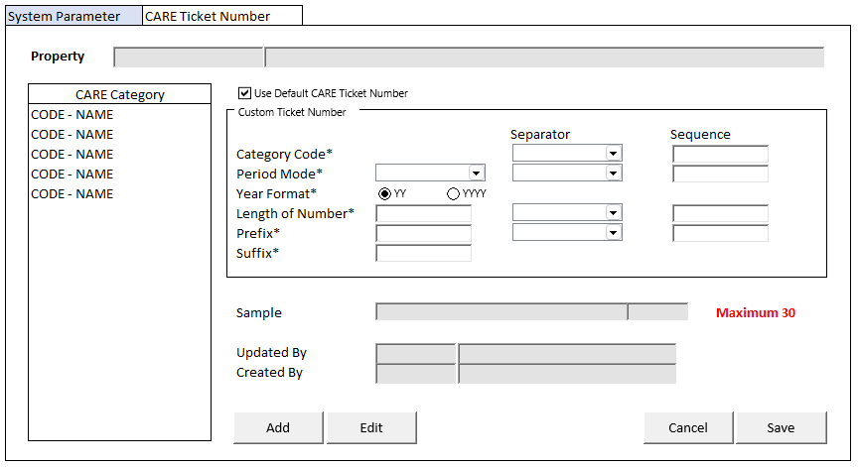

### BUTTON DEFINITION

|  |  |  |
| --- | --- | --- |
| **Button Name** | **Action** | **Enabled** |
| Add | Jalankan ADD NEW PROCESS | * + NOT on CRUD Mode   Hidden IF:   * + VAR_CARE_TICKET_NUMBER is not EMPTY |
| Edit | Jalankan EDIT PROCESS | * + NOT on CRUD Mode   Hidden IF:   * + VAR_CARE_TICKET_NUMBER is EMPTY |
| Cancel | Go to DISPLAY PROCESS | * + On CRUD Mode |
| Save | Jalankan SAVE & VALIDATION PROCESS | * + On CRUD Mode |

### ROLES

|  |  |
| --- | --- |
|  | **Test** |
| * User yg punya akses ke program |  |

### INITIAL PROCESS

|  |  |
| --- | --- |
|  | **Test** |
| * Set VAR_SEQUENCE_LIST (List<string>) = new List<String>() { “PREFIX”, “CATEGORY”, “PERIOD”, “NUMBER”} * Set VAR_SEQUENCE_DICT (Dictionary<string, string>) * **Load CARE Category List**   Jalankan RSP_GS_GET_GSB_CODE_LIST dengan parameter, simpan hasil ke VAR_CARE_CATEGORY_LIST dan VAR_SELECTED_CARE_CATEGORY   * + ‘BIMASAKTI’   + VAR_COMPANY_ID   + ‘_BS_CARE_CATEGORY’   + VAR_LANG_ID * **Load CARE Ticket Number**   Jalankan RSP_HD_GET_CARE_TICKET_NUMBER dengan parameter, simpan hasil ke VAR_CARE_TICKET_NUMBER   * + VAR_COMPANY_ID   + PARAM_PROPERTY_ID   + VAR_SELECTED_CARE_CATEGORY.CCODE * **Load Period Mode**   Jalankan RSP_GS_GET_GSB_CODE_LIST dengan parameter, simpan hasil ke VAR_PERIOD_MODE   * + ‘BIMASAKTI’   + VAR_COMPANY_ID   + ‘_NUMBERING_PERIOD_MODE’   + VAR_LANG_ID * **Load Year Format**   Set VAR_YEAR_FORMAT (as array of object) with VAR_CODE and VAR_NAME   * + Set VAR_CODE = ‘01’, ‘02’   + Set VAR_NAME = ‘YY’, ‘YYYY’ * **Load Delimiter**   Jalankan RSP_GS_GET_GSB_CODE_LIST dengan parameter, simpan hasil ke VAR_DELIMITER   * + ‘BIMASAKTI’   + VAR_COMPANY_ID   + ‘_BS_REFNO_DELIMITER’   + VAR_LANG_ID |  |

### DISPLAY PROCESS

#### FIELD DEFINITION

|  |  |  |  |
| --- | --- | --- | --- |
| **Name** | **Field** | **Type** | **Validation** |
| Property | PARAM_PROPERTY_ID | TextBox, Disabled |  |
|  | PARAM_PROPERTY_NAME | TextBox, Disabled |  |
| **CARE Category Grid** |  | **Data**: VAR_CARE_CATEGORY_LIST  **Type:** Navigator | Allow: -  View Only  On Selected Changed,  Set **VAR_SELECTED_CARE_CATEGORY** = Selected Row’s Data  **Load CARE Ticket Number** Jalankan RSP_HD_GET_CARE_TICKET_NUMBER dengan parameter, simpan hasil ke **VAR_CARE_TICKET_NUMBER**:   * + VAR_COMPANY_ID   + PARAM_PROPERTY_ID   + VAR_SELECTED_CARE_CATEGORY.CCODE |
| CARE Category | CCODE, CNAME  Set Display:  “CCODE – CNAME” | Textbox, Disabled |  |
| **Display Form** |  | **Data:** VAR_CARE_TICKET_NUMBER |  |
| Use Default CARE Ticket Number | LDEFAULT | Checkbox, Disabled | Enabled: on ADD & EDIT  Default Value: TRUE |
| **Custom Ticket Number** |  |  | Enabled:  on ADD & EDIT  LDEFAULT = FALSE |
| Category Code | CCARE_CATEGORY | Hidden | Value = VAR_SELECTED_CARE_CATEGORY.CCODE |
|  | CCARE_CATEGORY_SEPARATOR | Combobox, Disabled, Required  Isi combobox dengan VAR_DELIMITER  Set ValueField = CCODE  Set TextField = CNAME  Simpan hasil ke CCARE_CATEGORY_SEPARATOR | Set Default = “/”  On Value Changed,  Set VAR_SEQUENCE_DICT with Key “CATEGORY” =  CCARE_CATEGORY + CCARE_CATEGORY_SEPARATOR |
|  | ICARE_CATEGORY_SEQUENCE | NumericTextbox, Disabled, Required | Enabled: on ADD & EDIT  Decimal Places = 0  MinValue = 1  MaxValue = 3  Set Default = 1  On Value Changed,  VAR_SEQUENCE_LIST.Remove(“CATEGORY”)  VAR_SEQUENCE_LIST.Insert(**value**, “CATEGORY”)  Set IPERIOD_MODE_SEQUENCE = VAR_SEQUENCE_LIST.IndexOf(“PERIOD”)  Set INUMBER_LENGTH_SEQUENCE = VAR_SEQUENCE_LIST.IndexOf(“NUMBER”) |
| Period Mode | CPERIOD_MODE | Combobox, Disabled, Required  Isi combobox dengan VAR_PERIOD_MODE  Set ValueField = VAR_CODE  Set TextField = VAR_NAME  Simpan hasil ke CPERIOD_MODE | Enabled: on ADD & EDIT  Set Default = “Y”  On Value Changed,  Set VAR_SEQUENCE_DICT with Key “PERIOD” = IF CPERIOD_MODE = N, then “”  IF CPERIOD_MODE = P, then CYEAR_FORMAT + “MM” + CPERIOD_MODE_SEPARATOR  IF CPERIOD_MODE = Y, then CYEAR_FORMAT + CPERIOD_MODE_SEPARATOR |
| CPERIOD_MODE_SEPARATOR | Combobox, Disabled, Required  Isi combobox dengan VAR_DELIMITER  Set ValueField = CCODE  Set TextField = CNAME  Simpan hasil ke CPERIOD_MODE_SEPARATOR | Enabled: on ADD & EDIT  Set Default = “/”  On Value Changed,  Set VAR_SEQUENCE_DICT with Key “PERIOD” =  IF CPERIOD_MODE = N, then “”  IF CPERIOD_MODE = P, then CYEAR_FORMAT + “MM” + CPERIOD_MODE_SEPARATOR  IF CPERIOD_MODE = Y, then CYEAR_FORMAT + CPERIOD_MODE_SEPARATOR |
| IPERIOD_MODE_SEQUENCE | NumericTextbox, Disabled, Required | Enabled: on ADD & EDIT  Decimal Places = 0  MinValue = 1  MaxValue = 3  Set Default = 2  On Value Changed,  VAR_SEQUENCE_LIST.Remove(“PERIOD”)  VAR_SEQUENCE_LIST.Insert(**value**, “PERIOD”)  Set ICARE_CATEGORY_SEQUENCE = VAR_SEQUENCE_LIST.IndexOf(“CATEGORY”)  Set INUMBER_LENGTH_SEQUENCE = VAR_SEQUENCE_LIST.IndexOf(“NUMBER”) |
| Year Format | CYEAR_FORMAT | Combobox, Disabled, Required  Isi combobox dengan VAR_YEAR_FORMAT  Set ValueField = VAR_CODE  Set TextField = VAR_NAME  Simpan hasil ke CYEAR_FORMAT | Enabled: on ADD & EDIT  Set Default = ‘02’  Set VAR_SEQUENCE_DICT with Key “PERIOD” = IF CPERIOD_MODE = N, then “”  IF CPERIOD_MODE = P, then CYEAR_FORMAT + “MM” + CPERIOD_MODE_SEPARATOR  IF CPERIOD_MODE = Y, then CYEAR_FORMAT + CPERIOD_MODE_SEPARATOR |
| Length of Number | INUMBER_LENGTH | NumericTextbox, Disabled, Required | Enabled: on ADD & EDIT  Decimal Places = 0  On Value Changed,  Set VAR_SEQUENCE_DICT with Key “NUMBER” Add “9” as much as INUMBER_LENGTH + CNUMBER_LENGTH_SEPARATOR |
| CNUMBER_LENGTH_SEPARATOR | Combobox, Disabled, Required  Isi combobox dengan VAR_DELIMITER  Set ValueField = CCODE  Set TextField = CNAME  Simpan hasil ke CNUMBER_LENGTH_SEPARATOR | Enabled: on ADD & EDIT  Set Default = “/”  On Value Changed,  Set VAR_SEQUENCE_DICT with Key “NUMBER” Add “9” as much as INUMBER_LENGTH + CNUMBER_LENGTH_SEPARATOR |
| INUMBER_LENGTH_SEQUENCE | NumericTextbox, Disabled, Required | Enabled: on ADD & EDIT  Decimal Places = 0  MinValue = 1  MaxValue = 3  Set Default = 3  On Value Changed,  VAR_SEQUENCE_LIST.Remove(“NUMBER”)  VAR_SEQUENCE_LIST.Insert(**value**, “NUMBER”)  Set ICARE_CATEGORY_SEQUENCE = VAR_SEQUENCE_LIST.IndexOf(“CATEGORY”)  Set IPERIOD_MODE_SEQUENCE = VAR_SEQUENCE_LIST.IndexOf(“PERIOD”) |
| Prefix | CPREFIX | Textbox, Disabled, Required | Enabled: on ADD & EDIT  On Value Changed,  Set VAR_SEQUENCE_DICT with Key “PREFIX” CPREFIX + CPREFIX_SEPARATOR |
| CPREFIX_SEPARATOR | Combobox, Disabled, Required  Isi combobox dengan VAR_DELIMITER  Set ValueField = CCODE  Set TextField = CNAME  Simpan hasil ke CPREFIX_SEPARATOR | Enabled: on ADD & EDIT  Set Default = “/”  On Value Changed,  Set VAR_SEQUENCE_DICT with Key “PREFIX” CPREFIX + CPREFIX_SEPARATOR |
| IPREFIX_SEQUENCE | NumericTextbox, Disabled | Set Default = 0  Decimal Places = 0 |
| Suffix | CSUFFIX | Textbox, Disabled, Required | Enabled: on ADD & EDIT |
| Sample | CDISPLAY_SAMPLE | Textbox, Disabled | Set Display with format:  Set CDISPLAY_SAMPLE = string.Join(", ", VAR_SEQUENCE_LIST.Select(key => VAR_SEQUENCE_DICT[key])) + CSUFFIX |
| IDISPLAY_CHARACTER_COUNT | NumericTextbox, Disabled | Set IDISPLAY_CHARACTER_COUNT = Count characters from CDISPLAY_SAMPLE |
| **“Maximum 30”** |  |  |
| Updated By | CUPDATE_BY | Textbox, Disabled |  |
|  | DUPDATE_DATE | DateTimePicker, Disabled |  |
| Created By | CCREATE_BY | Textbox, Disabled |  |
|  | DCREATE_DATE | DateTimePicker, Disabled |  |

### ADD NEW PROCESS

#### ACTION

|  |
| --- |
|  |
| * Set **VAR_SAVE_MODE** = ‘ADD’ * Enabled Fields: ‘Use Default CARE Ticket Number’ * Set focus to column: ‘Use Default CARE Ticket Number’ |
| * Proses:   + ‘Save’ 🡪 Go To SAVE & VALIDATION PROCESS   + ‘Cancel’ 🡪 Go To DISPLAY PROCESS |

### EDIT PROCESS

#### ACTION

|  |
| --- |
|  |
| * Set **VAR_SAVE_MODE** = ‘EDIT’ * Enabled Fields: ‘Use Default CARE Ticket Number’ * Set focus to column: ‘Use Default CARE Ticket Number’ |
| * Proses:   + ‘Save’ 🡪 Go To SAVE & VALIDATION PROCESS   + ‘Cancel’ 🡪 Go To DISPLAY PROCESS |

### SAVE & VALIDATION PROCESS

#### VALIDATION

|  |  |  |
| --- | --- | --- |
| **Field** | **Condition** | **Validation Message** |
| Sequence | IF INUMBER_LENGTH_SEQUENCE = IPERIOD_MODE_SEQUNCE | No same sequence is allowed! |

#### ACTION

|  |
| --- |
|  |
| * **Validate** (See VALIDATION table)   IF Success, jalankan **Save System Parameter**  IF Failed, stay on Add/Edit Process   * **Save System Parameter**   Jalankan RSP_HD_MAINTAIN_CARE_TICKET_NUMBER dengan parameter,  @CCOMPANY_ID = VAR_COMPANY_ID  @CPROPERTY_ID = PARAM_PROPERTY_ID  @CCARE_CATEGORY = VAR_SELECTED_CARE_CATEGORY.CCODE  @LDEFAULT = ‘Use Default CARE Ticket Number’  @CCARE_CATEGORY_SEPARATOR = ‘Category Code Separator’  @ICARE_CATEGORY_SEQUENCE = ‘Category Code Sequence’  @CPERIOD_MODE = ‘Period Mode’  @CPERIOD_MODE_SEPARATOR = ‘Period Mode Separator’  @IPERIOD_MODE_SEQUENCE = ‘Period Mode Sequence’  @CYEAR_FORMAT = ‘Year Format’  @INUMBER_LENGTH = ‘Length of Number’  @CNUMBER_LENGTH_SEPARATOR = ‘Length of Number Separator’  @INUMBER_LENGTH_SEQUENCE = ‘Length of Number Sequence’  @CPREFIX = ‘Prefix’  @CPREFIX_SEPARATOR = ‘Prefix Separator’  @IPREFIX_SEQUENCE = ‘Prefix Sequence’  @CSUFFIX = ‘Suffix’  @CACTION = VAR_SAVE_MODE  @CUSER_ID = VAR_USER_ID |
| * Go to DISPLAY PROCESS |

# CR LIST

|  |  |  |
| --- | --- | --- |
| **CR** | **Description** | **Notes** |
| CR01  NS, 18 Dec 2024 | * Menambahkan CARE Invoice Tax ID * Menambahkan CARE Invoice Term of Payment * Menambahkan Auto Generate CARE Invoice * Menambahkan Flag Notification Email for Maintenance by Assigned Department * Menghapus Notification Email for Maintenance * Menghapus SLA Call Type for Maintenance * Menambahkan pemanggilan 2 lookup (Tax ID dan Payment Term) * Menghapus pemanggilan Call Type lookup |  |
| CR02  NS, 24 Dec 2024 | * Menambahkan CARE Ticket Number * Menambahkan Use Priority Apps |  |
| CR03  NS, 11 Maret 2024 | * Menambahkan Tab CARE Ticket Number * Mengubah pengambilan data untuk Combobox Period Mode * Perubahan label group box CARE Ticket Number 🡪 CARE Ticket Number (Default) |  |